Git Workflow

Objective
To understand the basic Git workflow including repository structure, tracking files, committing changes, and pushing code to GitHub.

Project Structure
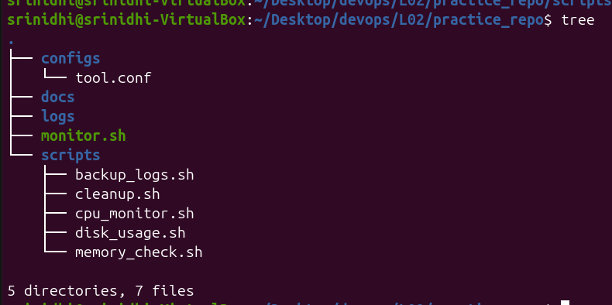
Description:
This screenshot shows the Linux Monitoring Toolkit project structure containing:
- monitor.sh
- scripts/
- logs/
- configs/
It demonstrates proper project organization.

Untracked Files
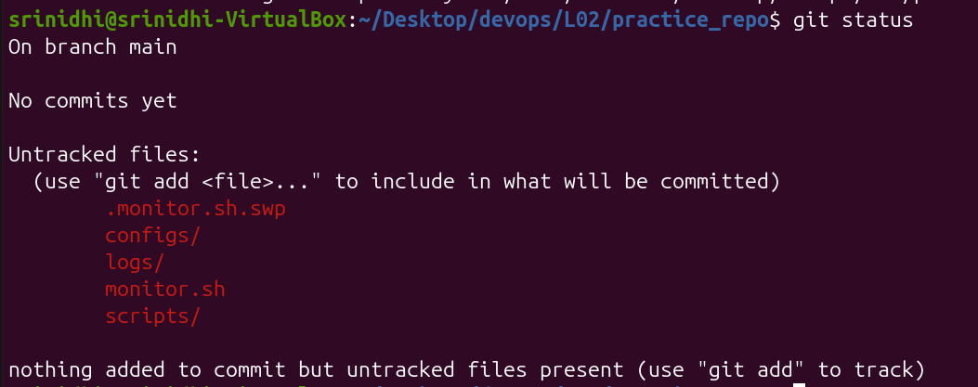
Description:
Git displays newly created files and folders that are not yet tracked.

Command
git status

Purpose
Shows:
- Current branch
- Modified files
- Untracked files
- Commit status

Commiting Project Files
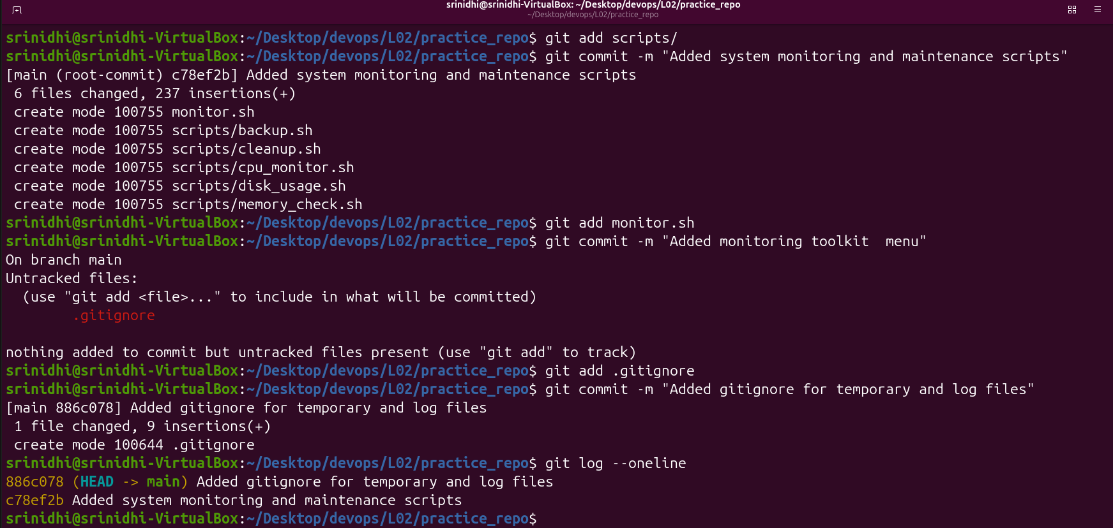

Commands
git add scripts/
git commit -m "Added system monitoring and maintenance scripts"

Purpose

git add
Stages files for commit.

git commit
Creates a snapshot of project changes.

Git Ignore
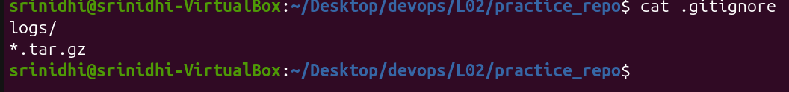

File Content
logs/
*.tar.gz

Purpose
.gitignore prevents unwanted files from being tracked such as:
- Log files
- Backup archives
- Temporary files

Outcome
Successfully created a Git repository, tracked project files, committed changes, and maintained repository cleanliness using .gitignore.

